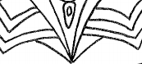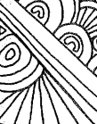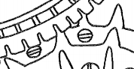

Name_________________________________ Glue this paper down in your sketchbook on to page 33.

**Expand the Drawings**: Look at the images printed below. You need to extend the lines all the way to the edges of the paper and include your own drawings to fill the space. Your goal is to disguise the original lines printed. You can draw recognizable objects or just work with lines and shapes that are abstract. There should be equal amounts of white paper and drawn lines when you finish the pencil design. Then use coloring supplies to fill in the white space. Think about outlining in sharpie and using colored pencils to create value by changing your hand pressure.

**Stay in your seats while you work. Be Responsible, Be Respectful, Be Safe, Be Caring. Take care of the art supplies and organize your supply baskets at the end of class. *Do not draw on your skin\***

Grading Rubric:

Excellent- 20 points: Page is filled with individual line designs and drawing looks careful and neat. The drawn lines connect into the printed lines with ease. Coloring is solid and neat.

Good- 17 points: Page is mostly filled with drawn lines but they do not connect easily to the printed lines. Drawing and coloring looks rushed.

Needs Improvement- 15 points: Page is incomplete, drawing and coloring looks sloppy and rushed.