Name________________________________________________ Period____P/W
Elements of Art: What you NEED to create a work of art.
1________Line____________________ A continuous mark made by a moving point.

2_______shape______________________an enclosed area made by connecting the ends of lines. Shapes are flat and 2 dimensional

3_______form____________________ 3-Dimensional Artwork like sculptures -OR- Represents 3D by including highlights and shadows in a drawing.
4________value_________________________the lightness or darkness of a color.
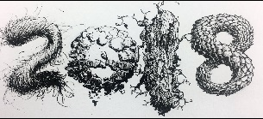
5_______texture____________________________represents the way a surface feels or looks like it would feel.

6_______color______________________________represents the 12 Hues on the color wheel: R, RO, O, YO, Y, YG, G,BG,B,BV,V,RV
Hue= name of the color Intensity- how bring or vivid the color is Value- the lightness or darkness of the color

7______space_____________________ the distance around objects. Represents depth by layering objects or making objects appear close or far away from you.
Background: objects appear smaller and far away
Middle ground: objects are in the middle area of the artwork
Foreground: objects are larger and more detailed
*Think of strategy to help you memorize the Elements of Art*
Large Furry Cats Sit Very Still Today
Line Form Color Shape Value Space Texture
Principles of Art: What you SEE within the design of the art. *Remember: BUMPERCars
1________balance__________________________ a sense of stability in the body of work by filling the space equally.

2________unity________________________ using similar elements to show a thought out plan. Keeping the artwork simple.

3________movement__________________________When your eye follows the lines throughout the artwork.

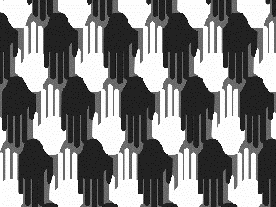
4_________pattern_______________________decorates the surfaces with planned, repeated units of design.

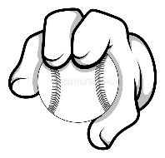

5________emphasis________________________the focal point that stands out.

6_______rhythm______________________________the visual beat of the artwork.

7______contrast_______________________________refers to opposites to catch the viewers eye because of the strong differences in the elements.

