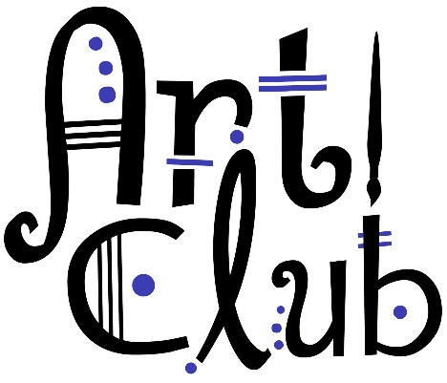
Art Club Meets Thursdays after school
beginning Aug 27, 2020. Open to the first 24 students who turn in this completed paperwork and $5.00

Art Club will meet weekly after school on Thursdays from 2:45-3:45pm in room 307. All students should have rides prearranged to pick them up in the front of the building after Art Club. Students who have paid to enroll in the after school PEAK program through Brownsburg Parks and Recreation hosted at East Middle school will take the “late bus” located outside door 14.

The following is a list of requirements and guidelines for club membership:
- A $5.00 fee will be charged to offset the cost of materials used for club activities. This one time fee covers the whole year. What a deal! Space is limited to the first 24 students who turn in permission slips and materials fee.
- Students attending club meetings need to be in room 307 no later than 2:45 for attendance and instructions. Students may bring snacks to Art Club if they choose.
- Students will be expected to follow the same general guidelines for conduct that are used in art class. All school rules apply! Art club is a privilege and students not abiding by the rules will be dismissed from the club without a refund.
- Student are allowed to listen to their own music if they choose but must use headphones.
- Students are responsible for cleaning up after themselves. We will clean-up precisely at 3:40 to allow enough time to “do it right”. Students must be picked up by 4:00 at door 1.
- Social distancing and mask wearing is strictly enforced. No sharing art supplies during Art Club!
- Students who participate in other extracurricular activities that conflict with Art Club will still be allowed to join but they should communicate with Mrs. Kendall when they will miss Art Club.
- Art club will not meet during Fall Break, Thanksgiving Break, Christmas Break, or Spring Break.
- Student’s must be picked up by 4:00pm as the club sponsor must supervise students until pick up. If lateness in pick up is persistent the following will occur: 2 late pick ups= discussion with parent, 3rd late pick up= final warning, 4th late pick up= dismissal from club.

Meeting Dates:
Aug 27 Jan 14, 21, 28 *No club Jan 7*
Sept 3, 10, 17, 24 Feb 4, 11, 25 *No club Feb 18*
Oct 1, 29 *No club Oct 8 which is Parent Conferences* March 4, 11 *No club March 18*
Nov 5, 12, 19 April 15, 22, 29 *No club April 8*
Dec 3, 10 *No club Dec 17* May 6, 13(Last Art Club)

Please complete the permission slip and return to Mrs. Kendall with the one time $5.00 materials fee BEFORE Thursday Aug 27, 2019. Checks are payable to BWMS.
Megan Kendall: Art Teacher/Art Club Sponsor mkendall@brownsburg.k12.in.us 317-852-3143 x 2517

Please complete this form and turn in to Mrs. Kendall with $5.00

___________________________________ has my permission to participate in the BWMS Art Club.
Student Name
I understand that the meetings are on Thursdays from 2:45-3:45 and will provide or arrange transportation for my child to be picked up in the front of the school building no later than 4:00pm.
*Students may also walk home if they live within walking distance or ride the “late bus” to BEMS for the PEAK program through Brownsburg Parks and Recreation.*

______________________________________________________ ________________
Parent/ Guardian Signature Date

Art Club will be canceled if I am unable to sponsor that day. I will do my best to send out an email if I am canceling. Please complete the information below and print neatly:
Parent/ Guardian Name____________________________________________________________________
Parent/ Guardian email ____________________________________________________________________
Parent/ Guardian phone #__________________________________________________________________
Student address__________________________________________________________________________
Student birthdate_________________________________________________________________________

- Please indicate below if you participate in other after school activities that will conflict with Art Club and a general idea of when those conflicts will occur. (For example: I participate in Track and Field so I cannot attend Art club during the spring).
____________________________________________________________________________________________________________________________________________________________________________________________________________________________________________________________

**Please note, you must pick up your child no later than 4:00pm as the club sponsor must supervise students until pick up. If lateness in pick up is persistent the following will occur: 2 late pick ups= discussion with parent, 3rd late pick up= final warning, 4th late pick up= dismissal from club.

